# Report for Andrew Richardson (2024-10-01 to 2024-10-31)

Average Bat Speed: 56.55

Average Rotational Acceleration: 8.76

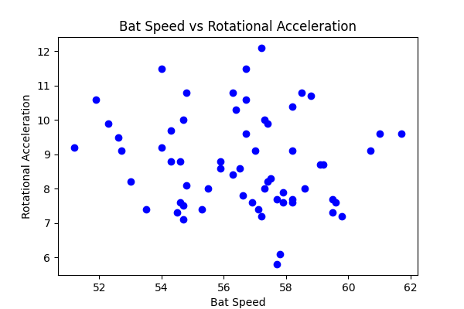

## Comments

Add comments here...